Lab1 CIS43 Due: 6/21/2016

Name: Nikhil Vytla

***Exercise: Ex 2.14, 2.16, 2.26 and 2.30***

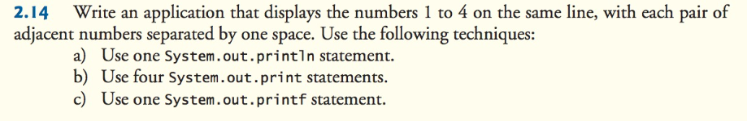

**package** Lab1;

**public** **class** Lab1 {

**public** **static** **void** main(String[] args) {

System.*out*.println("1 2 3 4");//part a

System.*out*.print("1 ");//part b

System.*out*.print("2 ");//part b

System.*out*.print("3 ");//part b

System.*out*.print("4");//part b

System.*out*.printf("%n1 2 3 4");//part c

}

}

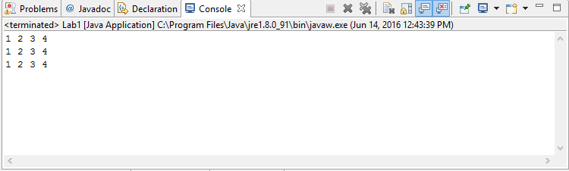

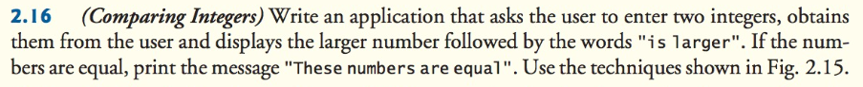

**package** Lab1Part1;

**import** java.util.Scanner;

**public** **class** Lab1Part1 {

**public** **static** **void** main(String[] args) {

Scanner input = **new** Scanner(System.*in*);

**int** number1; // first number to add

**int** number2; // second number to add

System.*out*.print("Enter first integer: "); // prompt

number1 = input.nextInt(); // read first number from user

System.*out*.print("Enter second integer: "); // prompt

number2 = input.nextInt(); // read second number from user

**if** (number1 == number2)

System.*out*.printf("These numbers are equal");

**if** (number1 > number2)

System.*out*.printf("%d is larger", number1, number2);

}

}

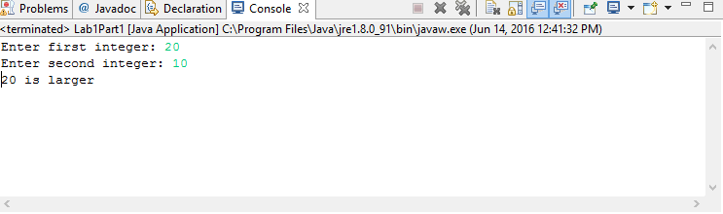

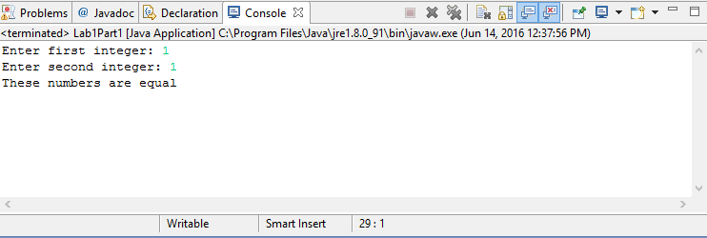



**package** Lab1Part2;

**import** java.util.Scanner;

**public** **class** Lab1Part2 {

**public** **static** **void** main(String[] args) {

Scanner input = **new** Scanner(System.*in*);

**int** x;//first number to read

**int** y;//second number to read

System.*out*.print("Enter first integer: "); // prompt

x = input.nextInt(); // read first number from user

System.*out*.print("Enter second integer: "); // prompt

y = input.nextInt(); // read second number from user

**if** (x%y != 0)

System.*out*.printf("%d is not a multiple of %d", x, y);

**if** (x%y == 0)

System.*out*.printf("%d is a multiple of %d", x, y);

}

}

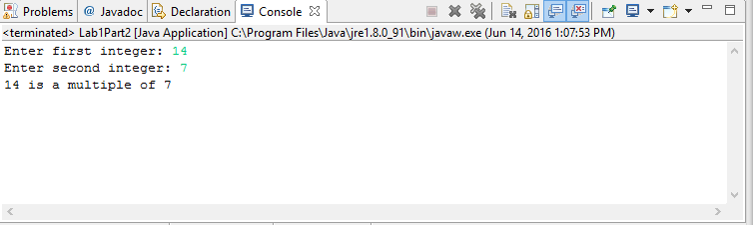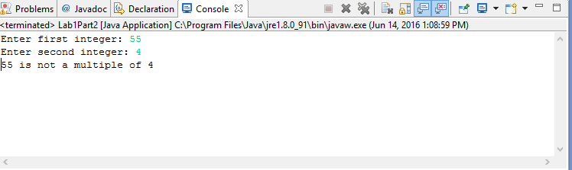

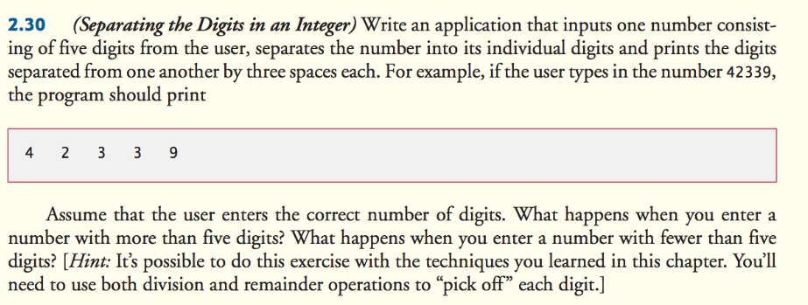

**package** Lab1Part3;

**import** java.util.Scanner;

**public** **class** Lab1Part3 {

**public** **static** **void** main(String[] args) {

Scanner input = **new** Scanner(System.*in*);

**int** n;

System.*out*.print("Enter a five digit integer: "); // prompt

n = input.nextInt(); // read integer from user

**int** n1 = n % 10000;

**int** ONE = n/10000;

**int** n2 = n1 % 1000;

**int** TWO = n1/1000;

**int** n3 = n2 % 100;

**int** THREE = n2/100;

**int** n4 = n3 % 10;

**int** FOUR = n3/10;

**int** n5 = n4 % 1;

**int** FIVE = n4/1;

System.*out*.printf("%d %d %d %d %d", ONE, TWO, THREE, FOUR, FIVE);

}

}

